**NEEDS UPADTES…..**

**Script standards**

If you wish to add new scripts to the system, make sure you put them in the folder located at: /home/notadmin/bin.

Each of your scripts **must** have a meaningful name. As you can see below, the restart-script does exactly as it sounds.. It restarts the system. The upgrade script upgrades all of the packages. And, for each script, make sure you provide a detailed readme on what the script does exactly (similar naming conventions).

**Make sure you give the proper permissions to your script for it to be executed**

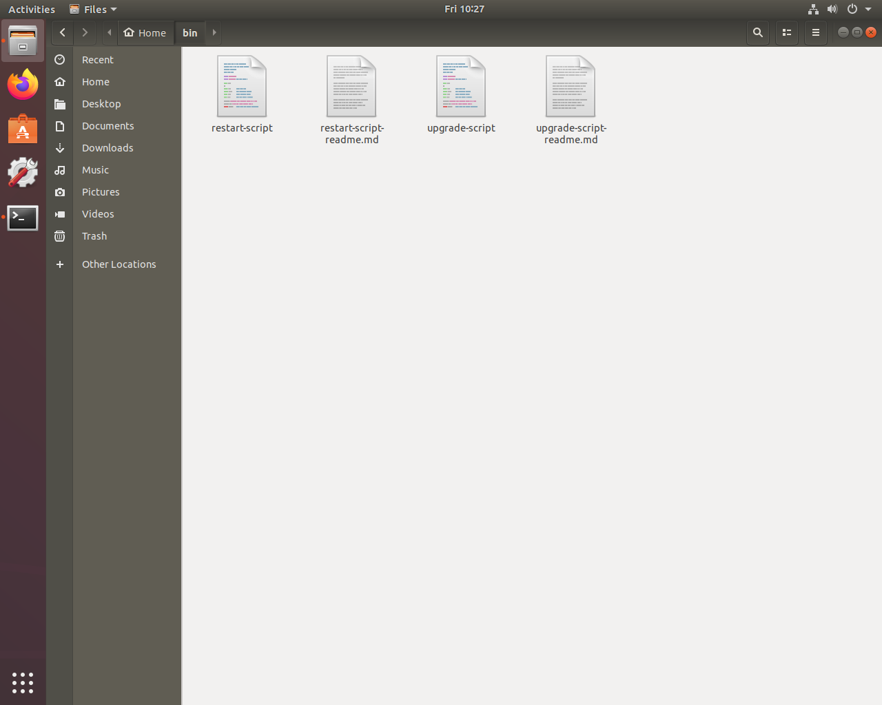

**Once your script is created, put it on the crontab (only if you think it’s necessary)**

The crontab is a powerful tool. It allows you to schedule tasks to be run automatically at a specific time.

Type this command into the terminal to open crontab: sudo crontab -e

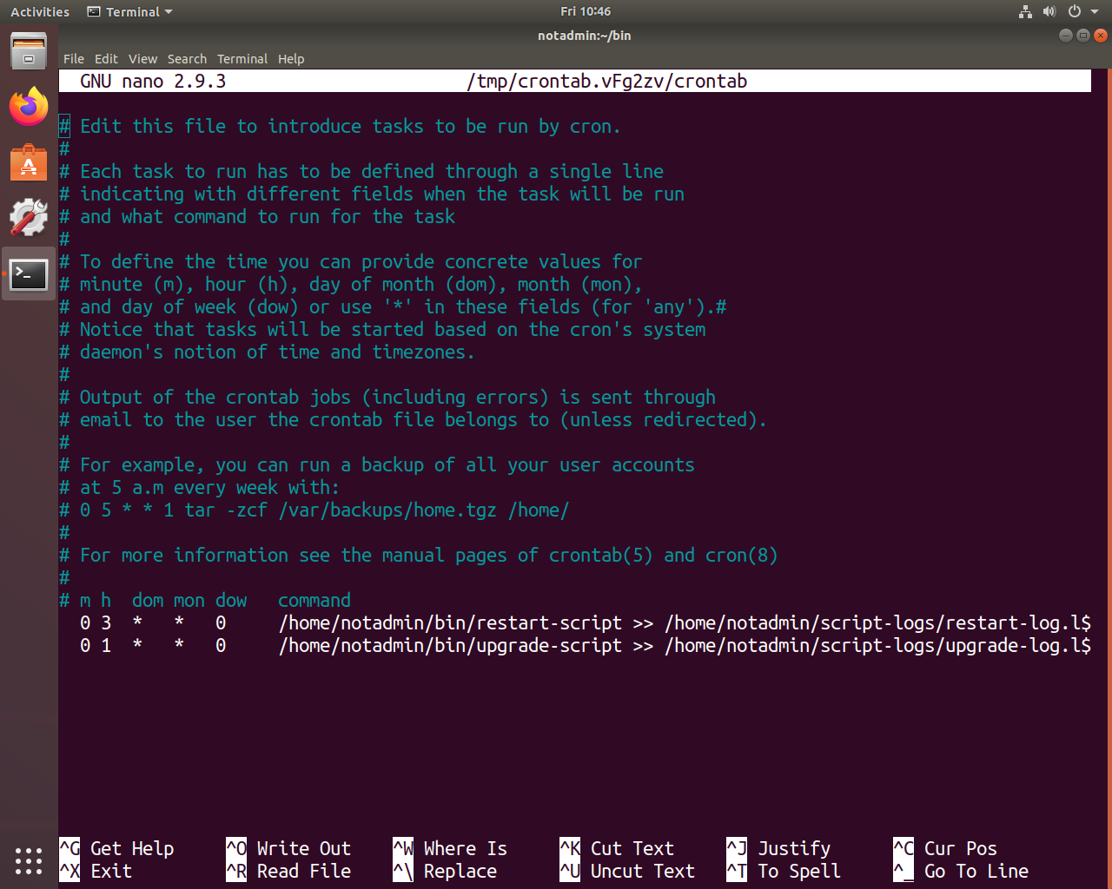

In order from left to right, put in the minute (m, 0-59), the hour (h, 0-23), the day of the month (dom, 1-31), the month (mon, 1-12), the day of the week (dow, 0-6), and the command you want executed. All of the output must be redirected to a log file to the specified path: /home/notadmin/script-logs/your-log-name.log

As shown below, the names of the log files are related to the script names. The restart script has a log named “restart-log.log” and the upgrade script has “upgrade-log.log”

